Nithin S
221IT085

IT150 Lab Assignment 5

1. 1. Write a program in c++ to perform operator overloading on unary operator on unary operator ++ and -- , use the following specification to write the program.
a) Create Class temp
b) Class temp has private access modifier and variable count.
c) In public section of class temp create a constructor of class temp
d) Assign value 5 to variable count
e) Overload operator ++ which will increase the value of count by 1.
f) Overload operator -- which will decrease the value of count by 1.

CODE

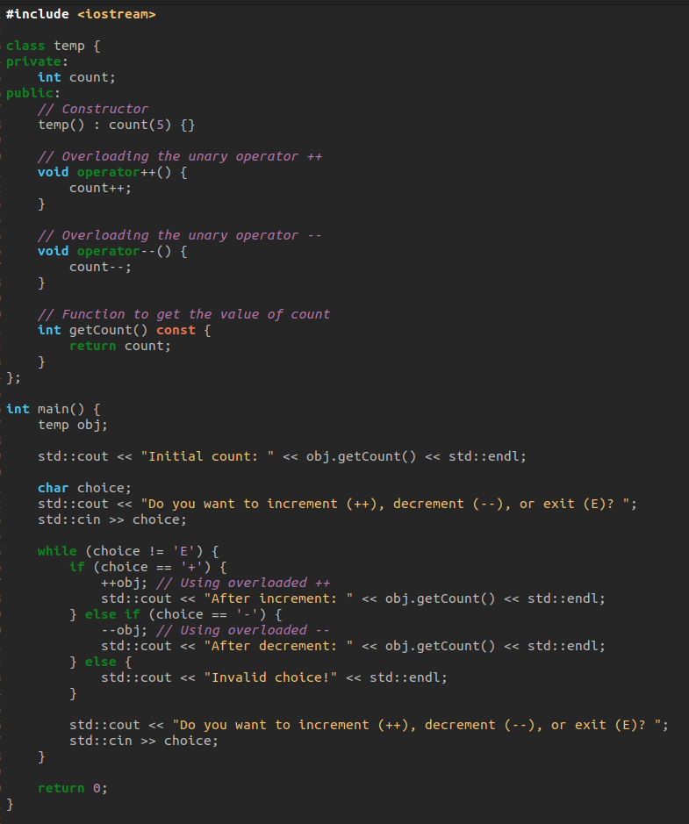
OUTPUT

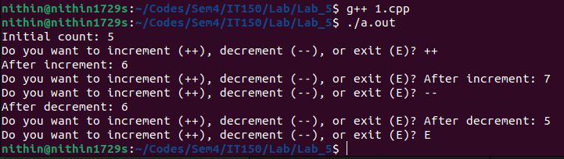

2.Write a C++ program to perform the addition and subtraction of two complex numbers using the binary (+) and (-) operator.

CODE

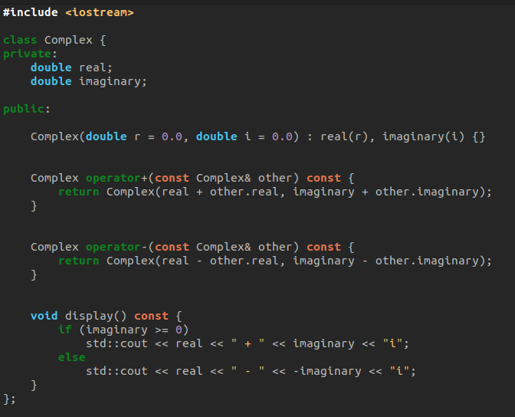

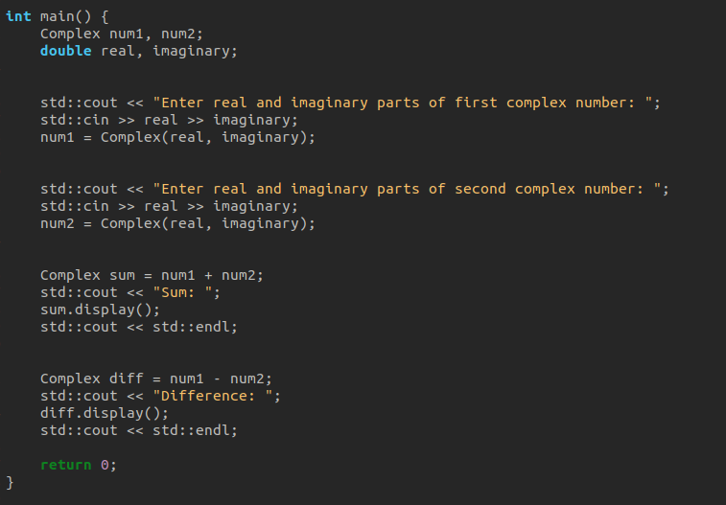

OUTPUT

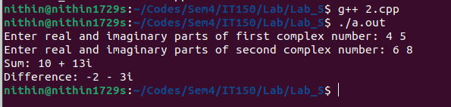

3. Run the below code and write your observation w.r.t virtual functions.

Given CODE

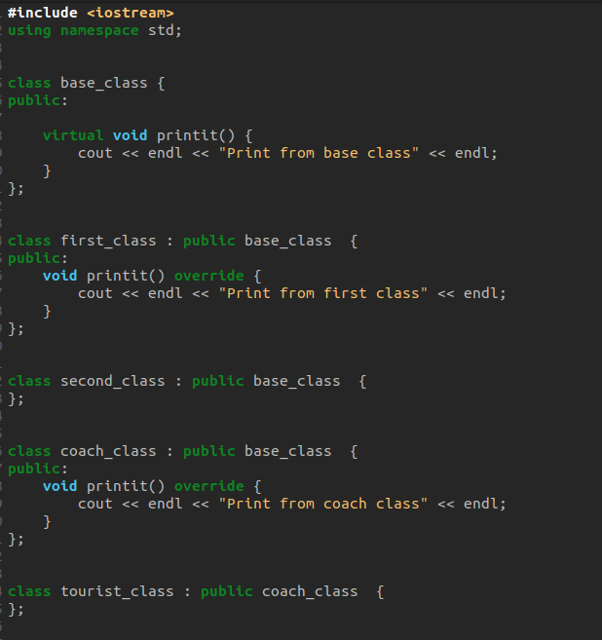

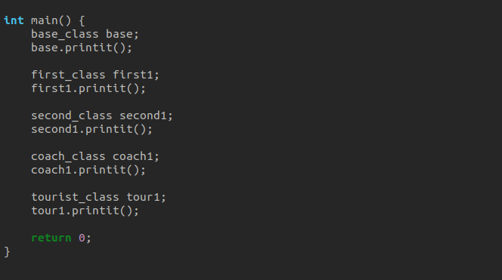

OUTPUT
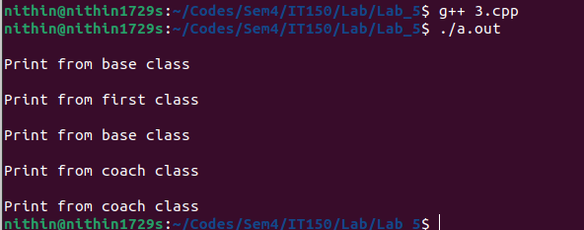

Observations:

Use of virtual Keyword: In the base_class, the printit() function is declared as virtual. This indicates that this function is intended to be overridden in derived classes.

Function Overriding in Derived Classes:

In first_class, coach_class, and tourist_class, the printit() function is redefined. This is function overriding, where the derived classes provide their own implementation of the printit() function.

In second_class, there's no explicit redefinition of the printit() function. In such a case, the printit() function of the base class will be invoked.

Dynamic Binding:

When an object of the base class (base_class) is created and its printit() function is called (base.printit()), the actual function called depends on the type of the object being referred to at runtime.

Similarly, for objects of derived classes (first_class, second_class, coach_class, tourist_class), dynamic binding ensures that the correct overridden version of printit() function is called based on the actual type of the object.

Main Function Usage:

In the main() function, objects of various classes are created and their printit() functions are called to demonstrate polymorphic behavior due to virtual functions.

This helps in illustrating how virtual functions work in a hierarchy of classes, ensuring that the appropriate function is called based on the object's dynamic type.

Overall, the code demonstrates the use of virtual functions and polymorphism in C++, allowing for more flexible and extensible class hierarchies.

4. Write a C++ program to :
a) perform function overriding by calling the overridden function of a member function from the child class
b) access overridden function using pointer of Base type that points to an object of Derived class
c) Access of Overridden Function to the Base Class
d) Access to Overridden Function

CODE

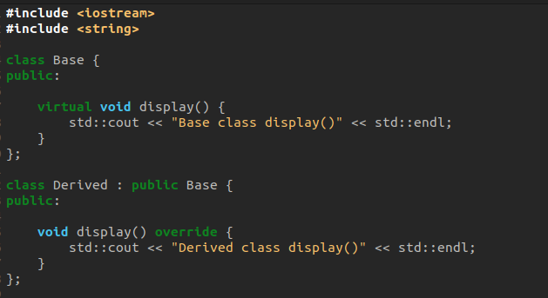

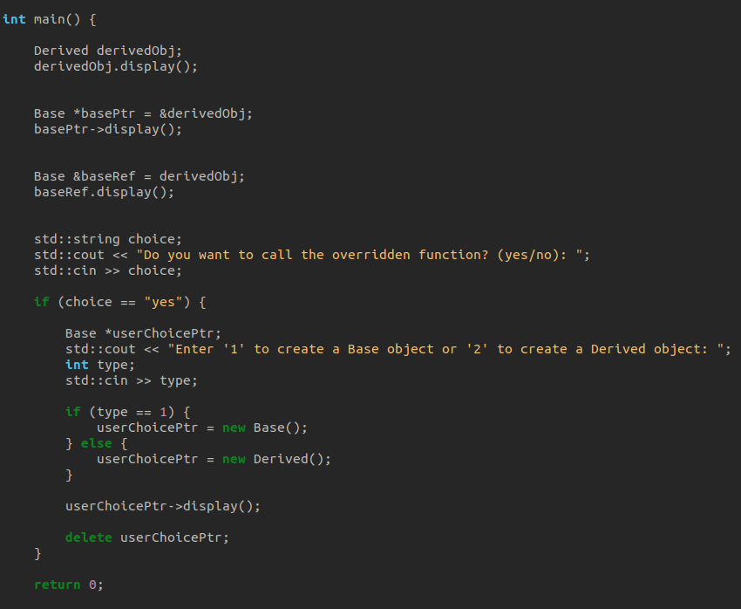

OUTPUT

